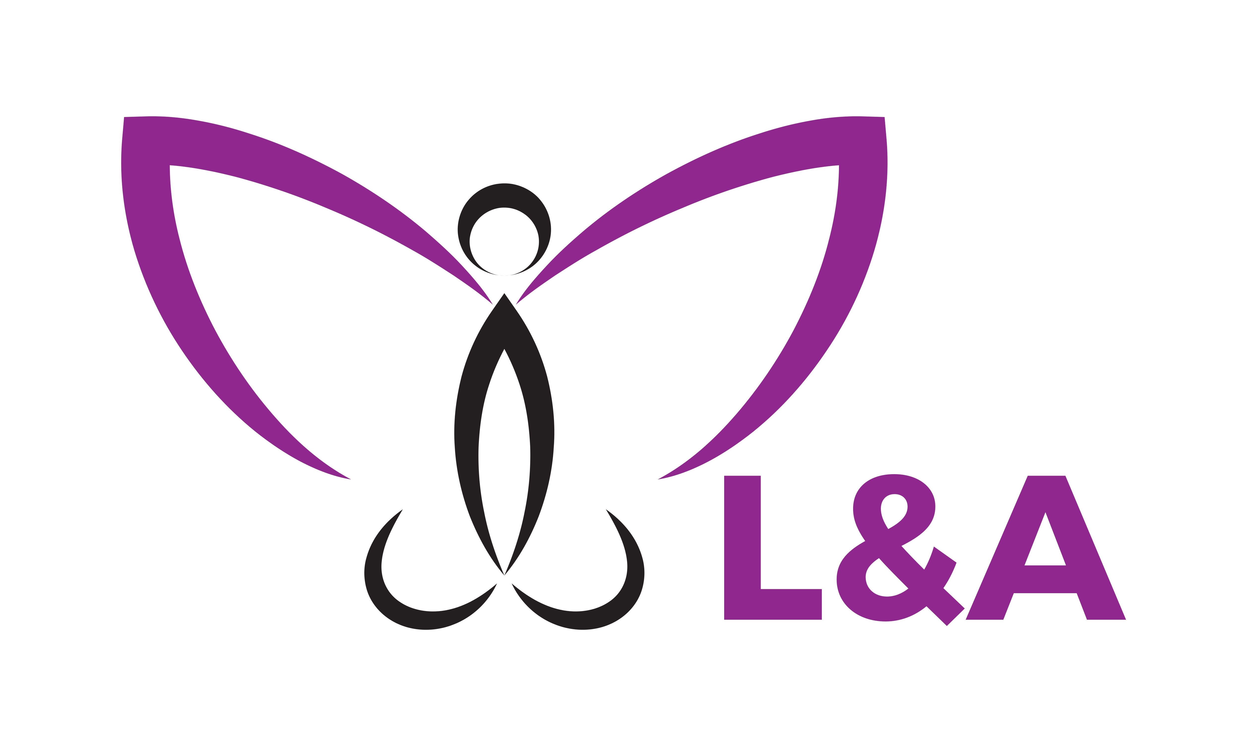•

Perth, Western Australia

The basis of business coaching

Business coaching is transferring and up skilling employees to a career goal either set by themselves or their organization. Some skills to which can be up skilled are:

* Communication for effective team performance
* Leadership skills that includes delegating, motiving team members and mentoring
* Self-management skills such as time management, work life balance and self-care.

Thriving on excellence, connectedness and contribution

“A coach is someone who tells you what you want to hear, who has you see what you don’t want to see, so you can be who you always knew you could be” – Tom Landry

“All coaching is, is taking a player where he can’t take himself” – Bill McCartney

L&A Health

Perth, Western Australia

www.landahealth.com

## Business Coaching

L&A Health

Partnered with an experience coach your employee will be put on a journey to which intends to enhance their performance. Side by side with the matched coach individuals learn to work within a team and get training on how to excel their performance. We have witnessed amazing results, with regards to individuals increasing their capacity to work with others in a way which benefits their team members and themselves. Also what has been witnessed is individuals reporting satisfaction and their private life, increases in relationship happiness and closeness.

Our experience with business coaching, business coaching creates a pathway to which excels your employees expectations and experiences. During this process their view points are dissolved with regards to barriers they are experiencing just like trained athletes, sometimes the individuals on the side lines, watching you perform are the best to give you the best advice on how to be and how to act during the times they experience a challenge or face challenges. Usually the challenge with most employees is how to engage with or manage other colleague interactions, most high performing managers need a coach to excel in their guidance.

### Coaching enables another to see what you can’t to improve performance

Website: www.landahealth.com

Email: info@landahealth.com

Phone: 0411551984

Fax: 08 9463 6395

In the workplace every employee or manager can up-skill or reach to a goal they want to obtain. Diamond training believes that coaching is a primary development tool to which unlocks and enhances employee performance and in turn increases their work satisfaction. Diamond Training creates a relationship and bond between coach and employee to which they are comfortable to exchange information to which creates a better result and outcome in the workplace.

# L&A Health

# Business Coaching

Website: www.landahealth.com

Email: info@landahealth.com

Phone: 0411551984

Fax: 08 9463 6395